**VPN Privacy and Security Report**

**VPN Setup Steps**

**1. VPN Sign-Up**

* Chose: ProtonVPN / Windscribe
* Registered with email and confirmed account.

**2. VPN Installation**

* Downloaded client from official site.
* Installed on Windows/macOS/Linux/Android.

**3. Connection**

* Opened VPN app.
* Connected to: Nearest available server or chose country (e.g., Netherlands, US).

**IP Address Verification**

* **Before VPN (original IP):**

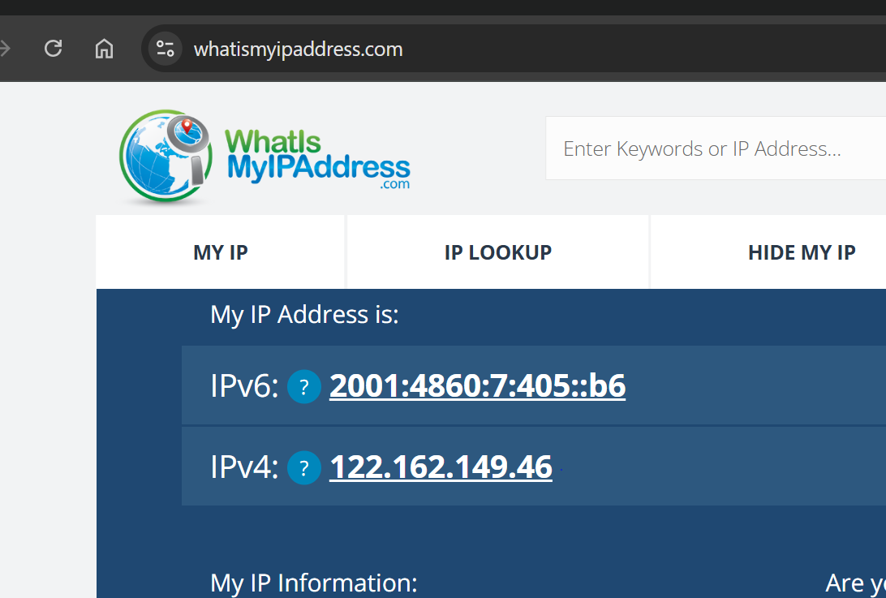

* **After VPN connected:**

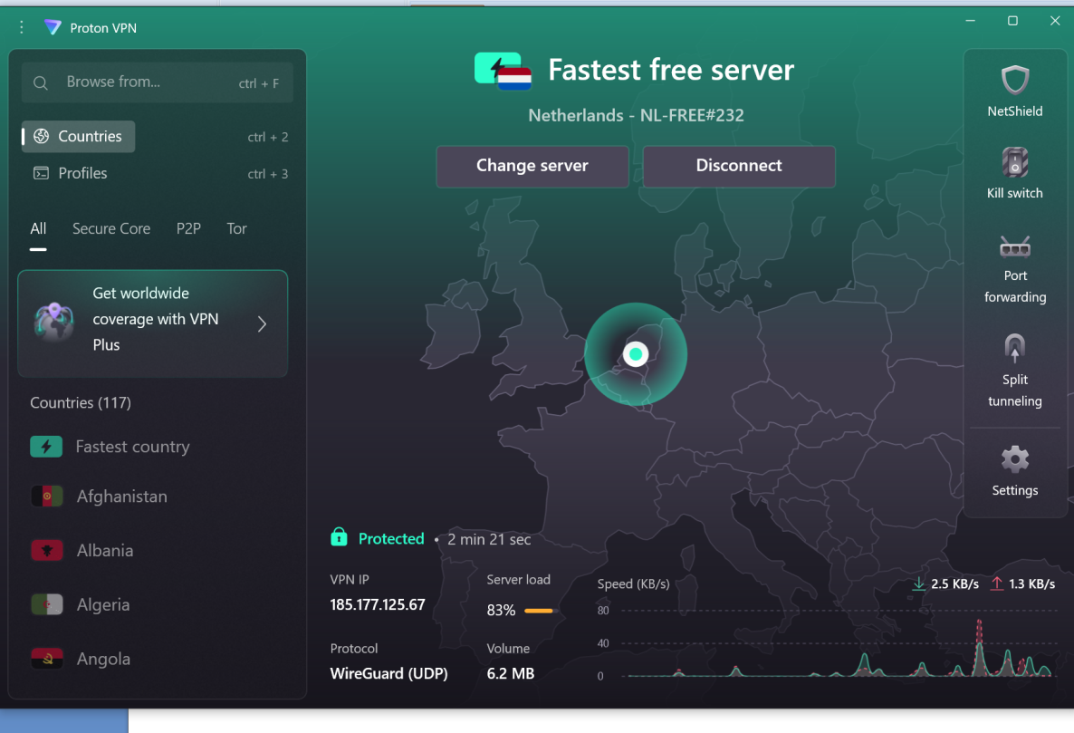

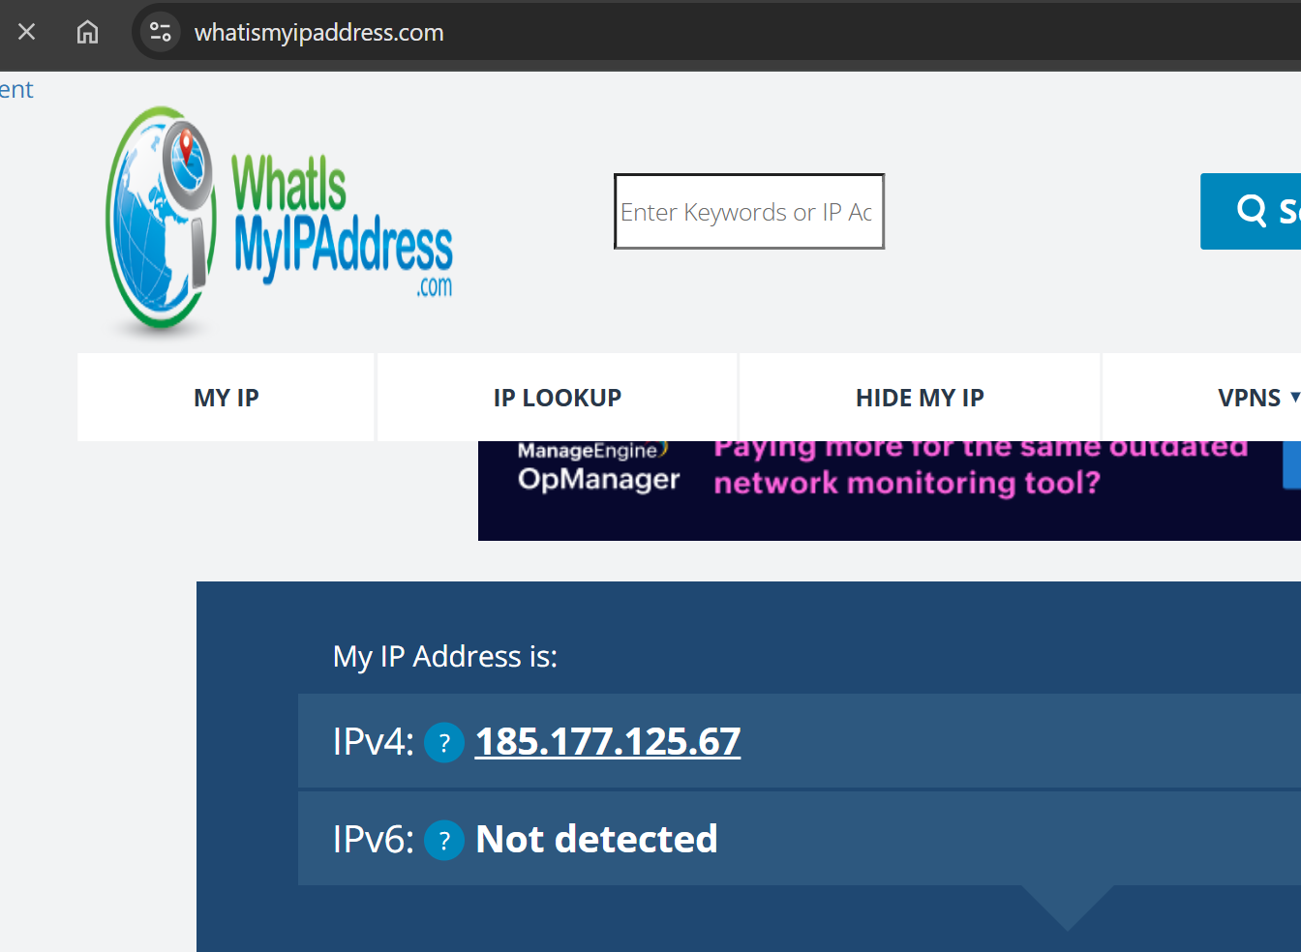

* **Verification Tool Used:** whatismyipaddress.com

IP address successfully changed.

**Encrypted Traffic Test**

* Opened a website: https://bbc.com or similar.
* Checked for lock icon in the address bar (SSL/TLS present).  
  Secure (HTTPS) browsing confirmed.

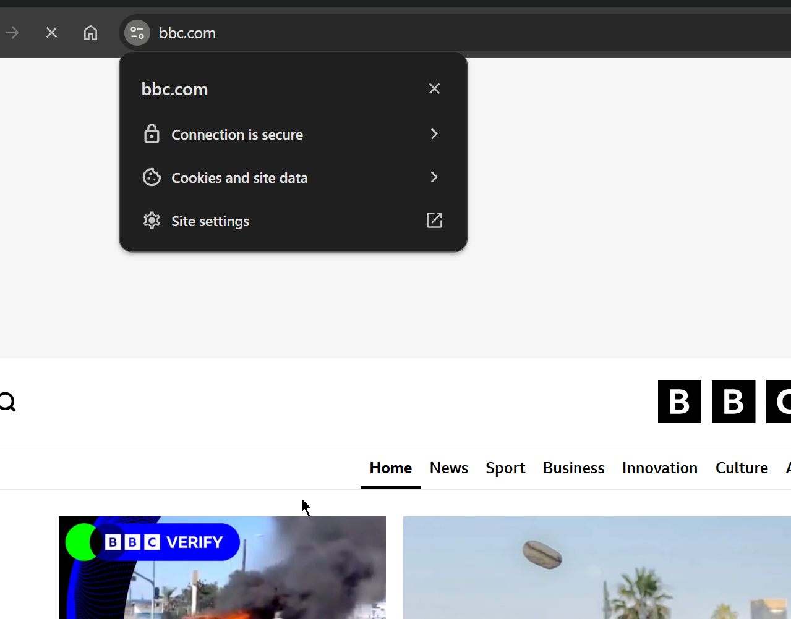

**Disconnection Test**

* Disconnected VPN.
* Reloaded IP check page:
  + IP reverted to original:

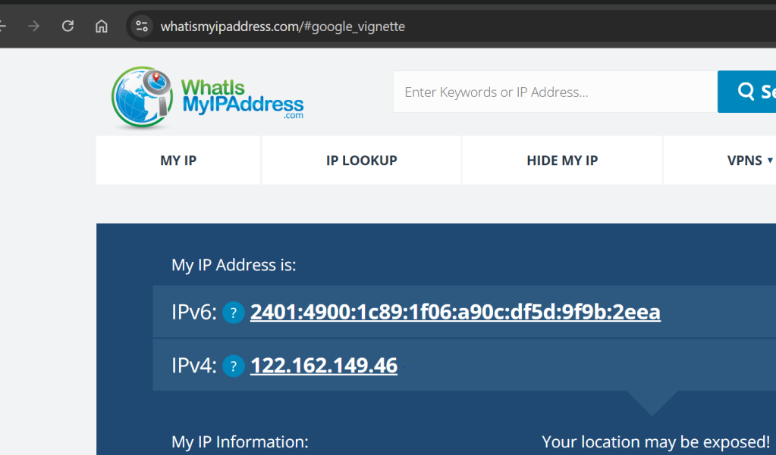

* Browsing speed slightly improved after disconnection.

**VPN Encryption & Privacy Features**

**Key Features of VPNs:**

* **Encryption Protocols:** OpenVPN, WireGuard, IKEv2
* **Encryption Level:** AES-256 (military-grade encryption)
* **DNS Leak Protection:** Ensures all DNS requests go through VPN.
* **Kill Switch:** Cuts off internet if VPN disconnects (not available in all free plans).

**Benefits vs. Limitations**

**Benefits**

* Masks real IP address to enhance anonymity.
* Secures data through encryption.
* Bypasses geographic restrictions and censorship.
* Useful on public Wi-Fi networks.

**Limitations**

* Free plans often limit server choice, speed, or data.
* Does not protect against phishing or malware.
* Some VPNs log data (check privacy policy).
* May slow down connection due to encryption overhead.